**News Release**

**Issue Date:** Wednesday, November 27, 2024

**Aberdeenshire Council encouraging use of online app to tackle noise disturbances**

Nearly 1,000 cases of nuisance noise have been reported since the introduction of Aberdeenshire Council’s noise app.

Launched as a trial back in November 2020, the app allows residents to make 30-second recordings on their smartphone each time there is a problem.

Around 1,500 people have downloaded the app and such as been the success of the system that it’s now widely used by the council’s Housing, Environmental Health and Community Safety services.

To-date, the council has seen the resolution of 862 cases following investigation, with 101 live cases where noise complaints are currently being looked into.

The most common complaints continue to be around domestic music, anti-social behaviour and noise from animals. Loud voices, live music, domestic or industrial machinery and TV and gaming have also led to complaints.

The Noise App allows residents to capture an offending noise quickly, rather than wait for officers to attend to witness the noise or to install noise-measuring equipment.

It also allows officers to start their investigations far earlier and take rapid action. Under the latest version of the app, users can now play back a recording before it’s submitted to ensure they have clearly captured the issue.

Cllr Anne Stirling, chair of the council’s Communities Committee, said: “First and foremost, I would encourage all residents and businesses to always be considerate to those living around them. We all have varying tolerances when it comes to noise disturbance and it can be particularly upsetting if the noise is coming from a neighbouring property. I am delighted that the Noise App has proved so successful and trust it will provide further benefit to those impacted by nuisance noise.”

Housing Manager Andrew Mackie added: “I would encourage anyone who is experiencing issues surrounding noise to download the Noise App, make a clear recording and provide us with the basic information required to allow us to investigate your complaint. By taking this simple step, it enables our officers to assess the options open to them in order to get a resolution. In many cases we’ve found that the recordings have clearly demonstrated to neighbours – be that residents or businesses – how they are inconveniencing people and that can lead to a speedy resolution.”

You can download the app at [www.thenoiseapp.com](http://www.thenoiseapp.com)

For guidance on some types of noise that may be regarded as a nuisance, visit: <https://www.aberdeenshire.gov.uk/environment/environmental-health/noise-pollution/>

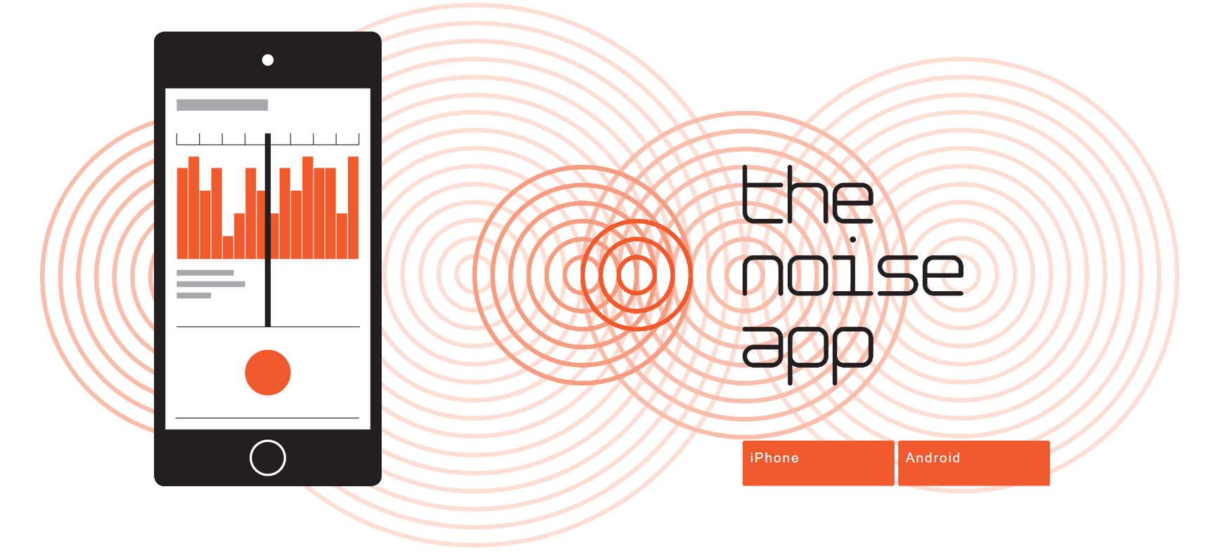

**ENDS**

Ken Duncan

**Communications Officer**

Customer & Digital Services

Aberdeenshire Council

**General media enquiries: 01467 538222**

Direct dial: 01467 535531

Email: [ken.duncan@aberdeenshire.gov.uk](mailto:ken.duncan@aberdeenshire.gov.uk)

Web: [www.aberdeenshire.gov.uk](http://www.aberdeenshire.gov.uk)